IT Transformation Hub — ITSM Module
Functional test report: pages, approval workflow, teams, assignment and ticket passing
Build tested: current main (UAT build), local copy of the UAT database. Date: 25 Oct 2026. Method: 57 automated API checks run as five different users (admin, service desk agent, employee, change manager, user without ITSM rights) plus a browser walk-through of all 8 ITSM pages.

1. Verdict
21 of 57 checks passed. 36 failed: 5 Critical, 14 High, 13 Medium, 4 Low.
The ITSM screens look complete, but the module is not ready for production use. The four things that matter most:
- Only administrators can use ITSM. Every create / update / approve call is admin-only. A service desk agent or an employee cannot log an incident or a service request, even when their role grants ITSM edit access. At the same time, any signed-in user can read every ticket.
- The approval workflow does not control anything. Approval steps are created, but approving them never approves the ticket, rejecting never stops it, levels are not enforced in order, and anyone with admin rights can simply set "Approval = Approved" on the form. A change approved by both L1 and L2 stays "Pending" and cannot be implemented.
- There are no real teams. A "team" is only a name in a drop-down. There are no members, team leads, queues, routing or "my team's tickets" view. Assignee is free text.
- Nobody is told anything, and hand-offs leave no trail. No emails for assignment, escalation, approval or resolution. Assignment and team changes are not written to ticket history; audit entries have no user name.

2. How it works today

Approval workflow
- Admin sets rules in ITSM › Approval Workflow: ticket type, level (L1, L2…), approver role (free text), condition (All / Priority / Severity) and sequence.
- When a ticket is created, one approval row per matching rule is created as Pending. Low-priority tickets are auto-approved.
- Approvals can only be actioned from the Problem and Service Request edit forms (not from Incidents or Changes), and only by a base-role Admin.
- Approving or rejecting only changes that row. The ticket's own status and "Approval status" are untouched. Change requests use a separate "Approval status" field on the form, which any admin can set by hand — this is the only thing that lets a change start.

Teams, assignment and ticket passing
- Teams = Settings list "IT groups" (Service Desk, Network Team…). Picking a team only stores its name on the ticket.
- Assign To = a user picker that stores the person's name as text. The API accepts any text.
- Passing a ticket to another team = editing the Assigned Group field. No history entry, no notification, no queue for the receiving team.
- Status can be changed to anything at any time (e.g. Closed → In Progress). Resolve does not need resolution notes. P1/S1 incidents are logged as "auto-escalated" in history but stay Open.

SLA
- Resolution SLA due time is set on new incidents from the SLA policy and breaches are shown correctly (tested). Response time is never measured. SLA applies to incidents only; service requests and problems show "No SLA".

3. Defects found
ID | Severity | Area | Check | What happened
CHG-03 | Critical | Change Requests | Approval cannot be bypassed by editing the field | An admin who is not the Change Manager / CAB set Approval = Approved on the form and started the change.
CHG-05 | Critical | Change Requests | Approving all levels approves the change | Both levels approved, but the change stays "Approval: Pending" and cannot start — the workflow never updates the ticket.
CHG-08 | Critical | Change Requests | The Change Manager (non-admin) approves L1; others cannot | The Change Manager (non-admin) gets HTTP 403. Only base-role Admin can approve; the role in the matrix is never checked.
RB-01 | Critical | Roles & Access | Service desk agent (non-admin, ITSM Incidents = Edit) logs and works an incident | Service Desk Agent (ITSM Incidents = Edit) gets HTTP 403 on create and update. All ITSM writes are admin-only; ITSM role permissions are ignored.
RB-02 | Critical | Roles & Access | Employee raises a service request / incident (self-service) | Employee with a self-service role gets HTTP 403 — employees cannot raise tickets.
APM-03 | High | Approval Workflow | Approver role is linked to real people | Approver is free text ("Change Manager"); not linked to any user or role.
ATT-01 | High | Attachments | Upload an attachment to a ticket | Upload fails (HTTP 500): file storage uses the old Replit service, which does not exist on AWS.
CFG-02 | High | Teams & Configuration | Teams have members (who belongs to which team) | Teams are only a list of names (Settings › IT groups). No members, team lead, queue or routing.
CHG-04 | High | Change Requests | Levels are approved in order (L1 before L2) | L2 (CAB) approved while L1 was still pending.
CHG-07 | High | Change Requests | Rejection stops the change | After L1 rejected, L2 could still approve; change not marked Rejected.
CHG-09 | High | Change Requests | Approvers see a "My approvals" queue | No "My approvals" list; approvers must open each ticket.
INC-05 | High | Incidents | Assign to a team member (ticket assignment) | Assignment saved, but ticket history only shows "Incident created" — no record of who assigned whom.
INC-06 | High | Incidents | Pass ticket to another team (L1 → Network Team) | Team changed, but nothing in history and nobody notified.
INC-11 | High | Incidents | P1/S1 incident is escalated | History says "auto-escalated" but the ticket status stays Open.
INC-13 | High | Incidents | Ticket numbers stay unique under parallel creation | 2 of 5 simultaneous creates failed with HTTP 500 — ticket number is "count + 1", so two users get the same number.
INC-18 | High | Incidents | Assignee / team is notified by email | No email on assignment, escalation, approval or resolution.
PRB-04 | High | Problems | Problem cannot close while its approval is pending | Problem closed while its approval was still Pending.
RB-03 | High | Roles & Access | User without ITSM access cannot read tickets | All incidents readable by any signed-in user (HTTP 200).
SR-02 | High | Service Requests | Fulfilment waits for approval | Request marked Completed while its approval was still Pending.
CHG-06 | Medium | Change Requests | Approver name recorded | Approver recorded as "Admin" instead of the person.
INC-02 | Medium | Incidents | Mandatory fields enforced | Missing title causes a database error (HTTP 500) instead of a clear message.
INC-03 | Medium | Incidents | Invalid priority / status rejected | Priority "Urgent!!" accepted (HTTP 201); no SLA can apply to it.
INC-04 | Medium | Incidents | Created-by is the signed-in user | Created By is taken from the browser request ("Someone Else"), not the signed-in user.
INC-07 | Medium | Incidents | Assignee must be a valid user / team member | Any free text accepted as assignee and team (HTTP 200).
INC-09 | Medium | Incidents | Resolve requires resolution notes | Resolved without resolution notes (HTTP 200).
INC-10 | Medium | Incidents | Invalid jump blocked (Closed → In Progress without reopen reason) | Closed ticket moved straight back to In Progress (HTTP 200); no reopen reason.
INC-14 | Medium | Incidents | Bulk update records history | Bulk status / assignee change writes no ticket history.
INC-16 | Medium | Incidents | Delete needs a reason and is audited | Deleted with no reason and no audit entry.
INC-17 | Medium | Incidents | Audit trail names the person | Audit entries have performed-by empty.
INC-20 | Medium | Incidents | First-response SLA is tracked | Response time in SLA policies is never measured (no first-response time).
SLA-02 | Medium | SLA Policies | SLA policy validation | Policy saved with empty name and negative hours (HTTP 201).
SR-04 | Medium | Service Requests | Requester sees own requests (self-service) | Every user sees every request; no "my tickets" view.
CHG-10 | Low | Change Requests | Standard (pre-approved) change skips CAB | Standard change still waits for 2 approvals ("Type:" condition ignored).
KB-02 | Low | Knowledge Base | Article validation | Missing title causes HTTP 500.
KB-03 | Low | Knowledge Base | Link KB article to incident resolution | No link between incidents and knowledge articles.
RB-04 | Low | Roles & Access | ITSM modules can be granted in Roles & Permissions | "Approval Workflow" is not a grantable module in Roles & Permissions.

4. Page-by-page observations
Page | Observation
All ITSM pages | Header breadcrumb always says "ITSM Dashboard", whatever page is open.
ITSM Dashboard | Numbers now come from the database correctly. SLA compliance shows "—" until SLA policies exist. Demo tickets on UAT should be removed with the clear script.
Incidents | List has no Reported By / Requested By and no time taken or age column. Assignee shown, team not shown. Row click does not open the ticket. No approval panel in the incident form. Free-text "Assign to…" in bulk actions.
Problems | Approval panel present. Linking incidents works (incident form › Link to Problem). Closing is not blocked by pending approval.
Change Requests | No approval panel at all — the L1/L2 approvals created from the matrix cannot be seen or actioned here. "Approval Status" and "Approved By" are plain form fields anyone with edit access can set.
Service Requests | "Requested By" is empty unless typed (not taken from the signed-in user). No time-taken column. Fulfilment not blocked by approval.
Knowledge Base | Create / edit / delete work for admin. Missing title gives a database error. Articles are not linked to incidents.
SLA Policies | Create / edit work. No validation (empty name, negative hours accepted).
Approval Workflow | Rule editor works and is admin-only. Approver is free text, not a person or role. "Approval Workflow" cannot be granted in Roles & Permissions.
Attachments | Upload fails on AWS (file storage still points to the old Replit service).

5. Your new requirement — listing screens
Every ITSM listing (Incidents, Service Requests, Problems, Changes) should show, per ticket:
- Raised by: the person who asked (taken automatically from the signed-in user, with employee code), and who it is for if raised on someone's behalf.
- Time taken: for open tickets, age since raised; for resolved / completed ones, total time to resolve; plus first-response time.
- Currently with: team and assignee, plus "waiting for approval by …" when an approval is pending.
- SLA: due time and on-track / at-risk / breached.
Today the incident list shows none of the first two, and the service request list shows "Requested By" only when typed by hand.

6. Recommended fix plan
Phase 1 is needed before anyone other than an admin uses ITSM. Phases 2–3 make it work like a service desk.
Phase | Scope
1 — Make it usable and safe | Module permissions for every ITSM API (read / edit / admin per module, same as Assets). Raised-by, created-by and approver taken from the signed-in user. Validation with clear messages. Safe ticket numbering (database sequence). Audit with user names. Fix attachments on AWS (store files on the server / S3). Breadcrumb fix.
2 — Approval workflow that drives the ticket | Approver = a role or named users from User Master. Levels in order; reject ends the flow; final approval sets the ticket to Approved and allows work to start; approval fields no longer editable by hand. "My approvals" inbox with Approve / Reject. Approval panel on all four ticket types. Standard changes pre-approved. Email to the current approver and to the requester on decision.
3 — Teams, assignment and ticket passing | Teams with members and a team lead (from User Master). Assign to a team member only. "My tickets" and "My team's queue" views. Transfer to another team with a reason, recorded in history and emailed. Status lifecycle rules (resolution notes, reopen with reason). P1 escalation sets status and emails the team lead. Listing columns from section 5: raised by, time taken, currently with, SLA. First-response SLA.

Each phase ships with its automated tests added to the test suite Excel, as for the Asset module.

Appendix A — Screens tested
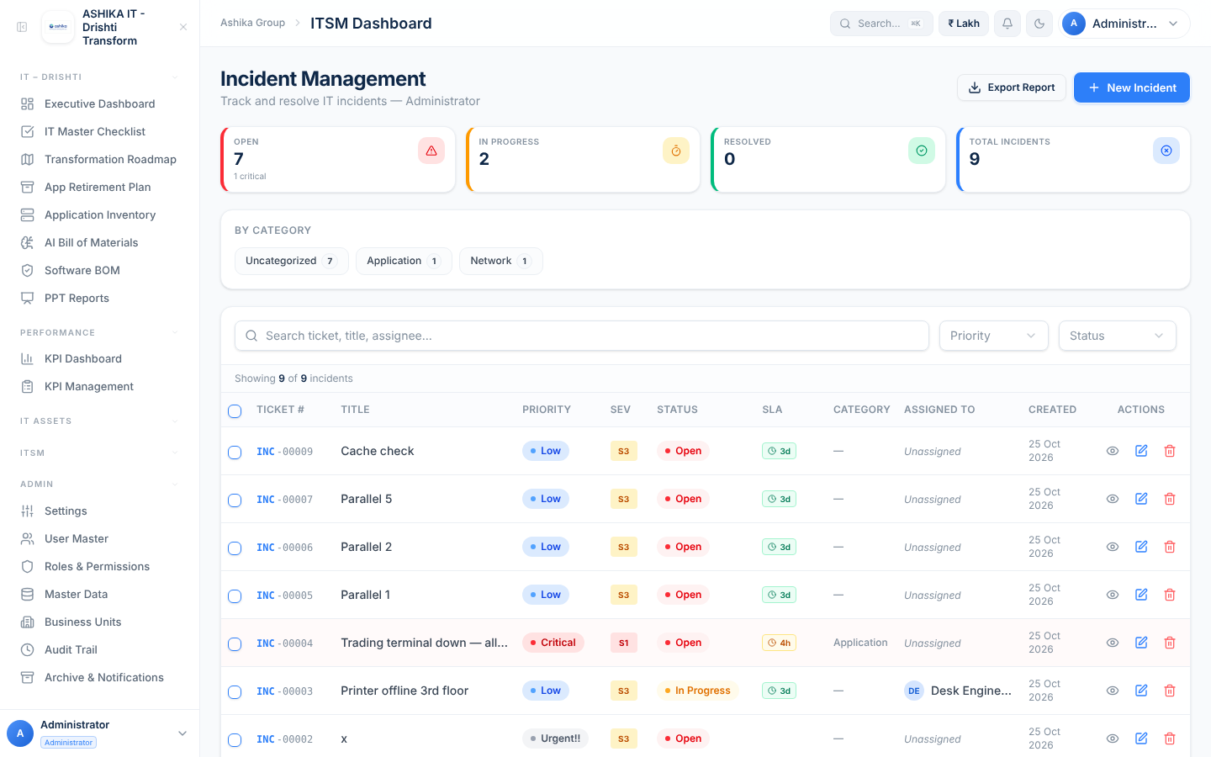

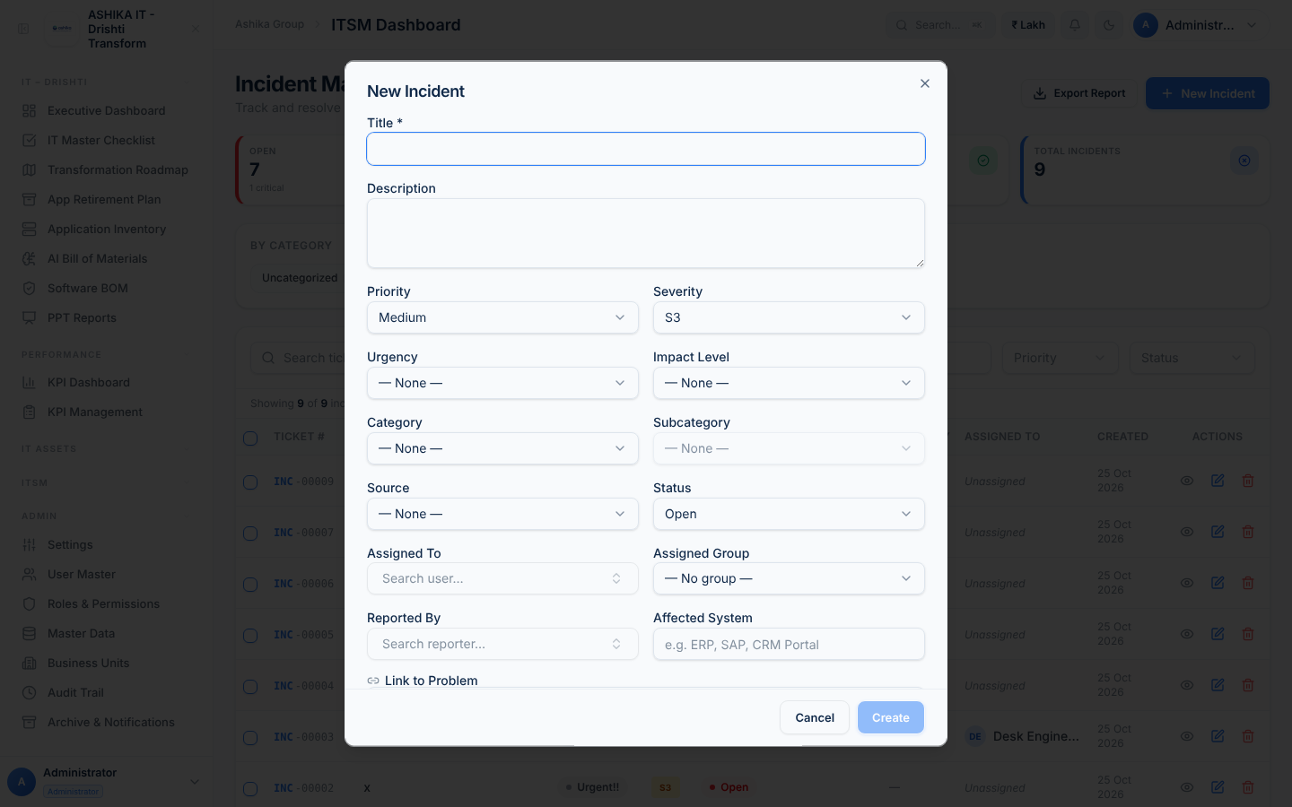

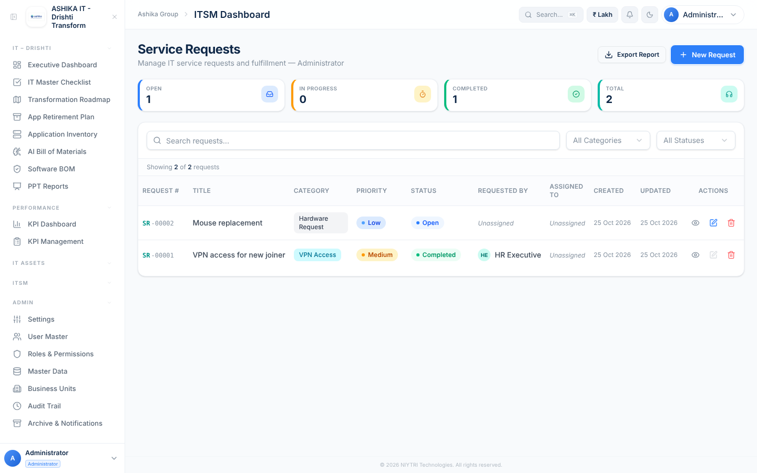

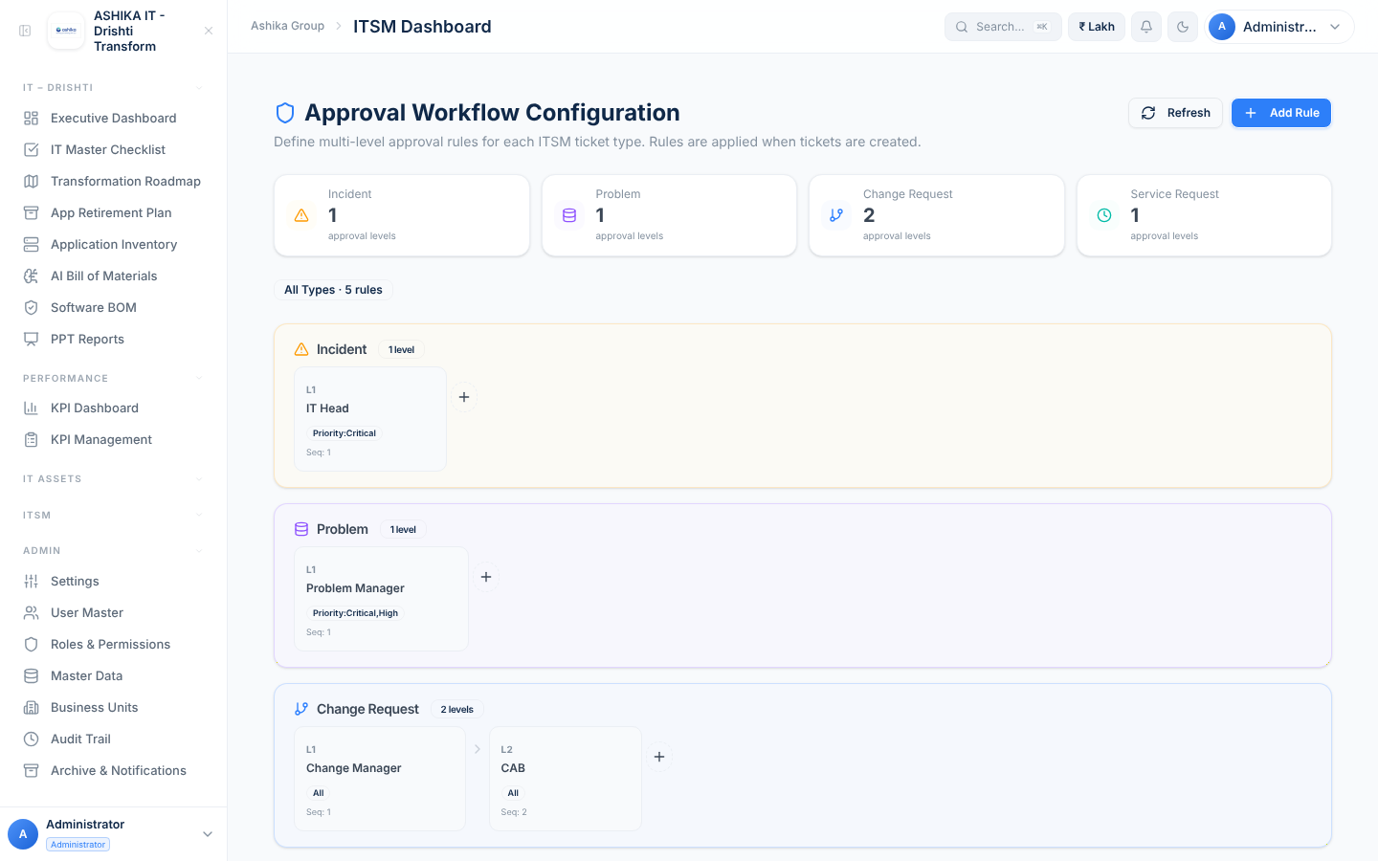

Appendix B — All automated checks
ID | Area | Check | Expected | Result | Severity
CFG-01 | Teams & Configuration | Admin defines IT support teams (assignment groups) | Groups saved and returned by GET /itsm-config | Pass
CFG-02 | Teams & Configuration | Teams have members (who belongs to which team) | Each team lists its members so tickets can be routed to a queue and members see their queue | Fail | High
CFG-03 | Teams & Configuration | Only admin can change ITSM configuration | HTTP 403 | Pass
SLA-01 | SLA Policies | Create SLA policies per priority | Created | Pass
SLA-02 | SLA Policies | SLA policy validation | HTTP 400 | Fail | Medium
SLA-03 | SLA Policies | Only admin / ITSM admin can change SLA policies | HTTP 403 | Pass
APM-01 | Approval Workflow | Configure approval matrix | Rules created | Pass
APM-02 | Approval Workflow | Approval matrix is admin-only | HTTP 403 | Pass
APM-03 | Approval Workflow | Approver role is linked to real people | Rule names an approver user / role from User Master so the right person gets the task | Fail | High
INC-01 | Incidents | Log an incident | HTTP 201; INC-00001; status Open; SLA due = created + 8h | Pass
INC-02 | Incidents | Mandatory fields enforced | HTTP 400 with message | Fail | Medium
INC-03 | Incidents | Invalid priority / status rejected | HTTP 400 | Fail | Medium
INC-04 | Incidents | Created-by is the signed-in user | createdBy = signed-in user (not client supplied) | Fail | Medium
INC-05 | Incidents | Assign to a team member (ticket assignment) | Assignee saved; history records "assigned to …" | Fail | High
INC-06 | Incidents | Pass ticket to another team (L1 → Network Team) | Group change recorded in history with who/when; new team notified | Fail | High
INC-07 | Incidents | Assignee must be a valid user / team member | HTTP 400 | Fail | Medium
INC-08 | Incidents | Status transitions follow the lifecycle | Each step saved; resolvedAt / closedAt set; history rows | Pass
INC-09 | Incidents | Resolve requires resolution notes | HTTP 400 | Fail | Medium
INC-10 | Incidents | Invalid jump blocked (Closed → In Progress without reopen reason) | HTTP 400 or reopen with reason | Fail | Medium
INC-11 | Incidents | P1/S1 incident is escalated | Status Escalated (or flag) + IT Head approval; notification | Fail | High
INC-12 | Incidents | Critical incident gets IT Head approval step | One Pending approval (L1 IT Head) | Pass
INC-13 | Incidents | Ticket numbers stay unique under parallel creation | All HTTP 201, unique numbers | Fail | High
INC-14 | Incidents | Bulk update records history | History row per ticket | Fail | Medium
RB-01 | Roles & Access | Service desk agent (non-admin, ITSM Incidents = Edit) logs and works an incident | HTTP 201 / 200 | Fail | Critical
RB-02 | Roles & Access | Employee raises a service request / incident (self-service) | HTTP 201 | Fail | Critical
RB-03 | Roles & Access | User without ITSM access cannot read tickets | HTTP 403 | Fail | High
RB-04 | Roles & Access | ITSM modules can be granted in Roles & Permissions | ITSM modules present (Incidents, Problems, Changes, KB, SLA, Service Requests, Approval Workflow) | Fail | Low
INC-16 | Incidents | Delete needs a reason and is audited | Reason required; audit entry | Fail | Medium
INC-17 | Incidents | Audit trail names the person | performedBy = signed-in user | Fail | Medium
INC-18 | Incidents | Assignee / team is notified by email | Email logged for the assignment | Fail | High
INC-19 | Incidents | SLA breach is detected | slaStatus "breached"; SLA Breached count ≥ 1 | Pass
INC-20 | Incidents | First-response SLA is tracked | firstResponseAt + response SLA status | Fail | Medium
PRB-01 | Problems | Raise a problem from repeated incidents and link them | PRB-00001; GET /incidents?problemId lists the linked incidents | Pass
PRB-02 | Problems | High-priority problem gets Problem Manager approval | One Pending approval | Pass
PRB-03 | Problems | Root cause → known error → closed | Saved with history | Pass
PRB-04 | Problems | Problem cannot close while its approval is pending | HTTP 400 | Fail | High
CHG-01 | Change Requests | Raise a change request | CHG-00001, status Draft, approval Pending, L1 + L2 approvals created | Pass
CHG-02 | Change Requests | Cannot implement before approval | HTTP 400 | Pass
CHG-03 | Change Requests | Approval cannot be bypassed by editing the field | HTTP 400/403 — only the approval workflow can approve | Fail | Critical
CHG-04 | Change Requests | Levels are approved in order (L1 before L2) | HTTP 400 | Fail | High
CHG-05 | Change Requests | Approving all levels approves the change | Change approvalStatus = Approved; can move to In Progress | Fail | Critical
CHG-06 | Change Requests | Approver name recorded | approverName = the signed-in approver | Fail | Medium
CHG-07 | Change Requests | Rejection stops the change | Change Rejected; further approvals blocked | Fail | High
CHG-08 | Change Requests | The Change Manager (non-admin) approves L1; others cannot | Change Manager HTTP 200; Asset Manager HTTP 403 | Fail | Critical
CHG-09 | Change Requests | Approvers see a "My approvals" queue | List of tickets waiting for my approval | Fail | High
CHG-10 | Change Requests | Standard (pre-approved) change skips CAB | No approvals or auto-approved | Fail | Low
SR-01 | Service Requests | Raise a service request | SR-00001 Open; Line Manager approval Pending | Pass
SR-02 | Service Requests | Fulfilment waits for approval | HTTP 400 | Fail | High
SR-03 | Service Requests | Low-priority request is auto-approved | Approvals Auto-Approved | Pass
SR-04 | Service Requests | Requester sees own requests (self-service) | Only own tickets | Fail | Medium
KB-01 | Knowledge Base | Publish a KB article | HTTP 201 | Pass
KB-02 | Knowledge Base | Article validation | HTTP 400 | Fail | Low
KB-03 | Knowledge Base | Link KB article to incident resolution | Incident references KB article | Fail | Low
ATT-01 | Attachments | Upload an attachment to a ticket | Upload URL returned (works on AWS) | Fail | High
RPT-01 | Reports | Master report lists all ticket types with approval stage | Rows for incidents, problems, changes, SRs with currentApprovalStage | Pass
DSH-01 | Dashboard | Dashboard numbers match the database | Counts equal | Pass
DSH-02 | Dashboard | Data refreshes immediately after an update | New count visible | Pass

